Tangent Segments Theorem
# Source: AI Source: Provided by: [Data Path: Persons Table -> ID Column: 1, Name_En Column: Motasem Essam] -> From: [ChatGPT] on [7/25/2026]
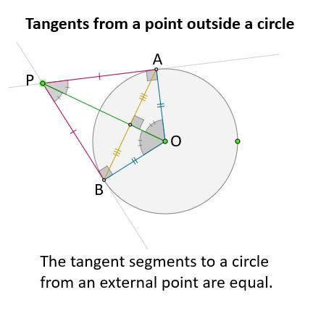
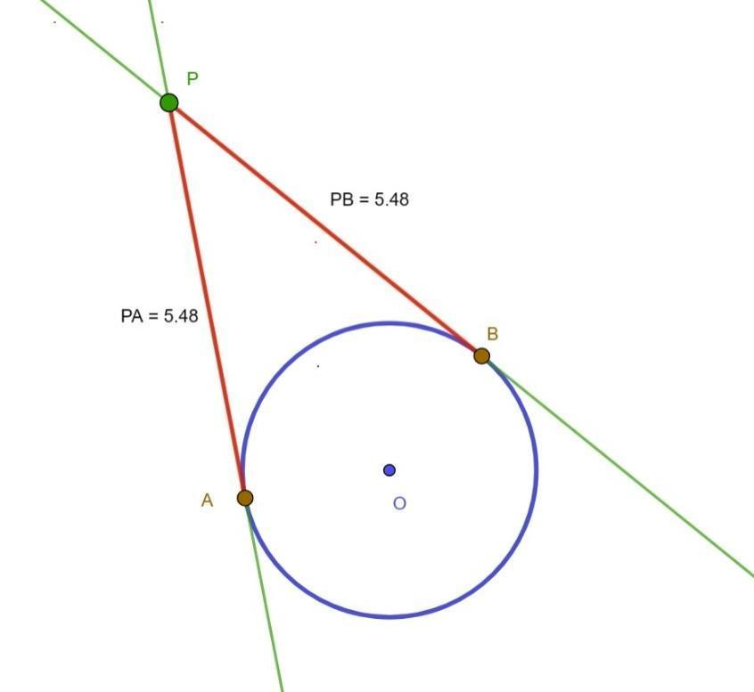
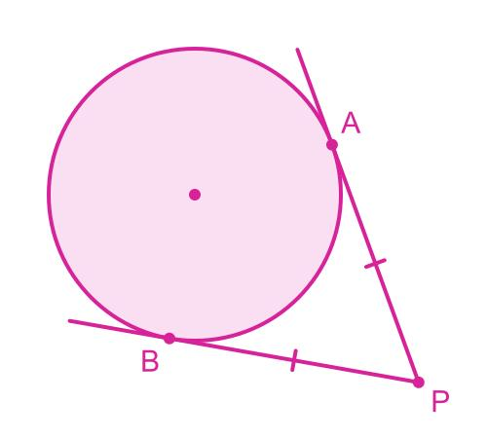
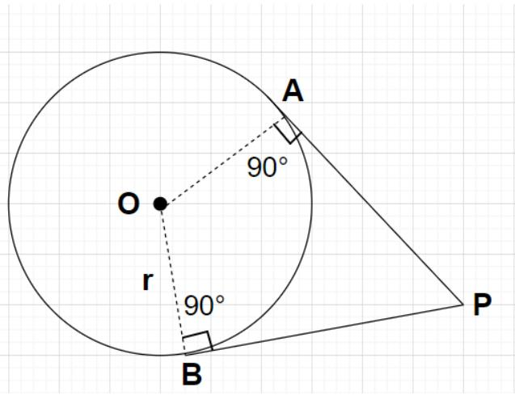
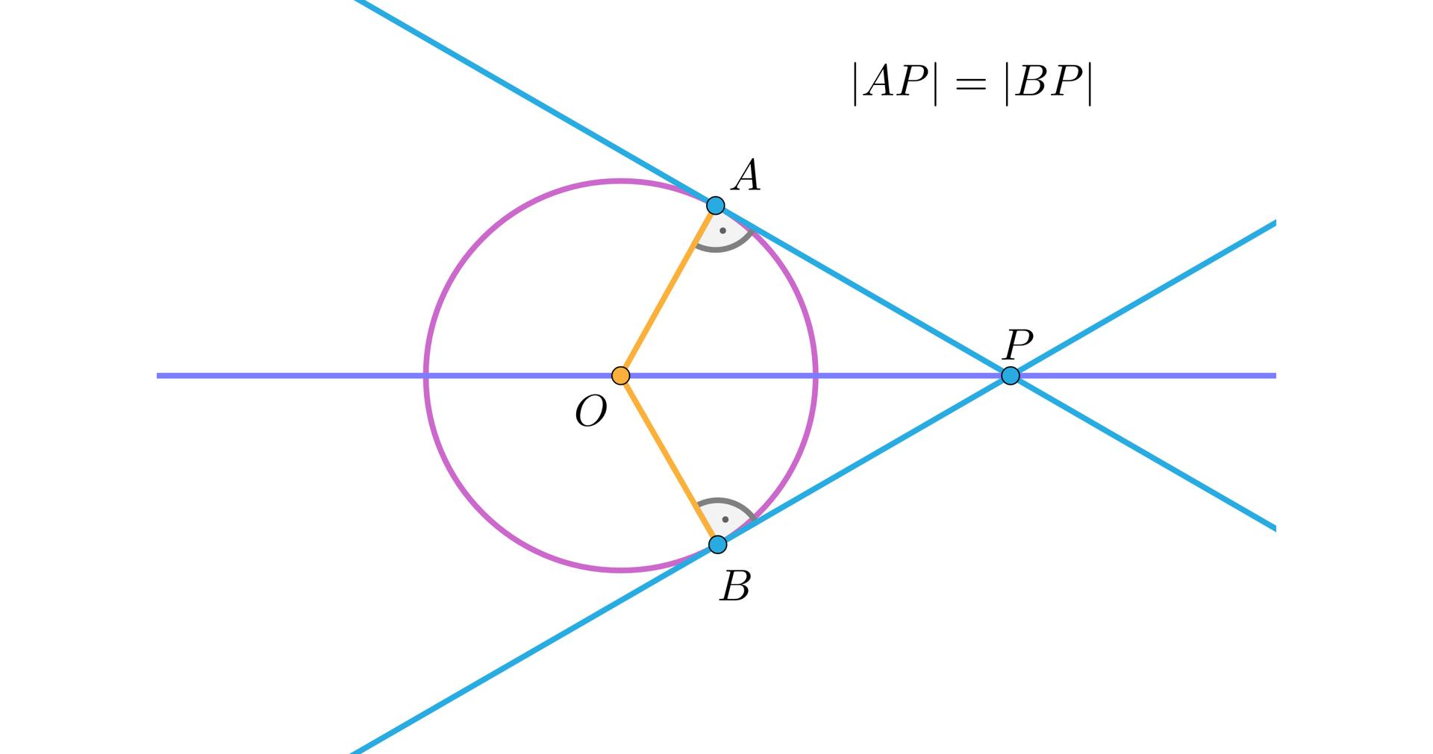

Definition
# Source: AI Source: Provided by: [Data Path: Persons Table -> ID Column: 1, Name_En Column: Motasem Essam] -> From: [ChatGPT] on [7/25/2026]
The Tangent Segments Theorem states that tangent segments drawn from the same external point to a circle are congruent.
If $P$is outside a circle and $PA$and $PB$are tangent segments touching the circle at $A$and $B$, then:
$$\boxed{PA=PB}$$
This theorem is also commonly called the Equal Tangent Segments Theorem.

Theorem Statement
# Source: AI Source: Provided by: [Data Path: Persons Table -> ID Column: 1, Name_En Column: Motasem Essam] -> From: [ChatGPT] on [7/25/2026]
Let $P$be a point outside a circle with center $O$.
Suppose:
- $PA$is tangent to the circle at $A$;
- $PB$is tangent to the circle at $B$.
Then:
$$\boxed{PA=PB}$$
Therefore, the two tangent segments have equal lengths.

Fundamental Concept
# Source: AI Source: Provided by: [Data Path: Persons Table -> ID Column: 1, Name_En Column: Motasem Essam] -> From: [ChatGPT] on [7/25/2026]
From the Tangent–Radius Theorem:
$$OA⊥PA$$
and:
$$OB⊥PB$$
Since $OA$and $OB$are both radii:
$$OA=OB$$
The two resulting right triangles are congruent, which proves:
$$\boxed{PA=PB}$$

Main Parts
# Source: AI Source: Provided by: [Data Path: Persons Table -> ID Column: 1, Name_En Column: Motasem Essam] -> From: [ChatGPT] on [7/25/2026]
For the configuration $PAB$:
- $P$= external point
- $A,B$= points of tangency
- $PA,PB$= tangent segments
- $O$= center
- $OA,OB$= radii
- $PA=PB$
The essential relationship is:
$$\boxed{PA=PB}$$

Proof
# Source: AI Source: Provided by: [Data Path: Persons Table -> ID Column: 1, Name_En Column: Motasem Essam] -> From: [ChatGPT] on [7/25/2026]
Consider triangles:
$$△OAP$$
and:
$$△OBP$$
Step 1 — Radii are equal
Because $OA$and $OB$are radii of the same circle:
$$\boxed{OA=OB}$$
Step 2 — Both are right angles
By the Tangent–Radius Theorem:
$$OA⊥PA$$
and:
$$OB⊥PB$$
Therefore:
$$∠OAP=∠OBP={90}^{∘}$$
Step 3 — Common hypotenuse
Both triangles have the same hypotenuse:
$$OP=OP$$
Step 4 — Congruence
Thus:
$$△OAP≅△OBP$$
by RHS (Right angle–Hypotenuse–Side) congruence.
Therefore:
$$\boxed{PA=PB}$$

Example 1 — Finding a Tangent Segment
# Source: AI Source: Provided by: [Data Path: Persons Table -> ID Column: 1, Name_En Column: Motasem Essam] -> From: [ChatGPT] on [7/25/2026]
Suppose:
$$PA=12$$
and both $PA$and $PB$are tangent segments from $P$.
Then:
$$PA=PB$$
Therefore:
$$\boxed{PB=12}$$

Example 2 — Finding an Unknown
# Source: AI Source: Provided by: [Data Path: Persons Table -> ID Column: 1, Name_En Column: Motasem Essam] -> From: [ChatGPT] on [7/25/2026]
Suppose:
$$PA=3x+2$$
and:
$$PB=5x-8$$
Since the tangent segments are equal:
$$3x+2=5x-8 \\ 10=2x \\ \boxed{x=5}$$
Therefore:
$$PA=3\left(5\right)+2=17$$
and:
$$PB=5\left(5\right)-8=17$$
So:
$$\boxed{PA=PB=17}$$

Example 3 — Using the Radius and Center Distance
# Source: AI Source: Provided by: [Data Path: Persons Table -> ID Column: 1, Name_En Column: Motasem Essam] -> From: [ChatGPT] on [7/25/2026]
Suppose:
$$OP=13$$
and the circle has radius:
$$r=5$$
Because $OA⊥PA$, triangle $OAP$is a right triangle.
Using the Pythagorean theorem:
$$OP^{2}=OA^{2}+PA^{2} \\ {13}^{2}=5^{2}+PA^{2} \\ 169=25+PA^{2} \\ PA^{2}=144 \\ \boxed{PA=12}$$
By the Tangent Segments Theorem:
$$\boxed{PB=12}$$
Thus both tangent segments are 12 units long.

Relationship to Tangent–Radius Theorem
# Source: AI Source: Provided by: [Data Path: Persons Table -> ID Column: 1, Name_En Column: Motasem Essam] -> From: [ChatGPT] on [7/25/2026]
The two theorems are closely connected.
Tangent–Radius Theorem
$$\boxed{OA⊥PA}$$
and:
$$\boxed{OB⊥PB}$$
Tangent Segments Theorem
$$\boxed{PA=PB}$$
The first theorem provides the right triangles needed to prove the second.

Relationship to Power of a Point
# Source: AI Source: Provided by: [Data Path: Persons Table -> ID Column: 1, Name_En Column: Motasem Essam] -> From: [ChatGPT] on [7/25/2026]
The tangent segment also gives the power of the external point $P$.
If $PA$is tangent:
$$\boxed{Pow⁡\left(P\right)=PA^{2}}$$
Since:
$$PA=PB$$
we also have:
$$\boxed{Pow⁡\left(P\right)=PB^{2}}$$
Therefore:
$$\boxed{PA^{2}=PB^{2}}$$

Relationship to Secants
# Source: AI Source: Provided by: [Data Path: Persons Table -> ID Column: 1, Name_En Column: Motasem Essam] -> From: [ChatGPT] on [7/25/2026]
Suppose $P$has two tangent segments and a secant.
For tangent $PA$:
$$Pow⁡\left(P\right)=PA^{2}$$
For secant $P-C-D$:
$$Pow⁡\left(P\right)=PC⋅PD$$
Therefore:
$$\boxed{PA^{2}=PC⋅PD}$$
This is the Tangent–Secant Theorem.

Geometric Consequences
# Source: AI Source: Provided by: [Data Path: Persons Table -> ID Column: 1, Name_En Column: Motasem Essam] -> From: [ChatGPT] on [7/25/2026]
Because:
$$PA=PB$$
the point $P$is equidistant from the two points of tangency.
Also, because:
$$OA=OB$$
and:
$$OP=OP$$
the triangles $OAP$and $OBP$are congruent.
As a consequence, $OP$bisects the angle between the two tangent segments:
$$\boxed{∠APO=∠OPB}$$
Thus, the line from the external point to the center is an angle bisector of the angle formed by the two tangents.

Tangent Chord Configuration
# Source: AI Source: Provided by: [Data Path: Persons Table -> ID Column: 1, Name_En Column: Motasem Essam] -> From: [ChatGPT] on [7/25/2026]
If $P$is outside the circle and two tangents touch the circle at $A$and $B$, then:
$$PA=PB$$
and:
$$OA=OB$$
Therefore both $P$and $O$are equidistant from $A$and $B$.
Consequently, the line $PO$is the perpendicular bisector of chord $AB$:
$$\boxed{PO⊥AB}$$
and:
$$\boxed{PO\text{ bisects }AB}$$

Important Properties
# Source: AI Source: Provided by: [Data Path: Persons Table -> ID Column: 1, Name_En Column: Motasem Essam] -> From: [ChatGPT] on [7/25/2026]
- Tangent segments from the same external point are equal.
- If $PA$and $PB$are tangent segments:
$$\boxed{PA=PB}$$
- The radii to the points of tangency are perpendicular to the tangent segments.
- The two tangent segments and corresponding radii form congruent right triangles.
- The line joining the external point to the center bisects the angle between the two tangents.
- The center-to-external-point line is the perpendicular bisector of the chord joining the points of tangency.
- The common tangent length satisfies:
$$\boxed{PA=\sqrt{PO^{2}-r^{2}}}$$
- The tangent length squared equals the power of the external point:
$$\boxed{PA^{2}=Pow⁡\left(P\right)}$$

Classification
# Source: AI Source: Provided by: [Data Path: Persons Table -> ID Column: 1, Name_En Column: Motasem Essam] -> From: [ChatGPT] on [7/25/2026]
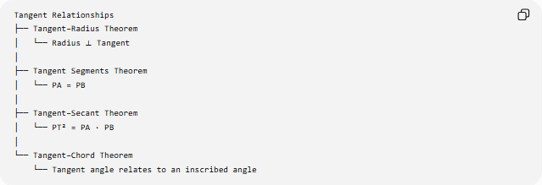
Tangent Relationships
├── Tangent–Radius Theorem
│ └── Radius ⟂ Tangent
│
├── Tangent Segments Theorem
│ └── PA = PB
│
├── Tangent–Secant Theorem
│ └── PT² = PA · PB
│
└── Tangent–Chord Theorem
└── Tangent angle relates to an inscribed angle

Tangent Segments vs. Secant Segments
# Source: AI Source: Provided by: [Data Path: Persons Table -> ID Column: 1, Name_En Column: Motasem Essam] -> From: [ChatGPT] on [7/25/2026]
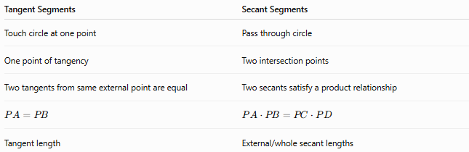
Tangent Segments | Secant Segments
Touch circle at one point | Pass through circle
One point of tangency | Two intersection points
Two tangents from same external point are equal | Two secants satisfy a product relationship
$$PA=PB$$ | $$PA⋅PB=PC⋅PD$$
Tangent length | External/whole secant lengths

Special Case — Point on the Circle
# Source: AI Source: Provided by: [Data Path: Persons Table -> ID Column: 1, Name_En Column: Motasem Essam] -> From: [ChatGPT] on [7/25/2026]
The theorem specifically concerns two tangent segments from the same external point.
A point lying on the circle has only one tangent line at that point.
Therefore, the equal-tangent relationship requires an external point from which two distinct tangents can be drawn.

Applications
# Source: AI Source: Provided by: [Data Path: Persons Table -> ID Column: 1, Name_En Column: Motasem Essam] -> From: [ChatGPT] on [7/25/2026]
The Tangent Segments Theorem is used in:
- Circle geometry
- Tangent-length problems
- Triangle and angle problems
- Circle constructions
- Power of a point
- Secant–tangent problems
- Coordinate geometry
- CAD and geometric design
- Engineering
- Computer graphics

Key Formula Summary
# Source: AI Source: Provided by: [Data Path: Persons Table -> ID Column: 1, Name_En Column: Motasem Essam] -> From: [ChatGPT] on [7/25/2026]
Main theorem
$$\boxed{PA=PB}$$
Tangent length
$$\boxed{PA=PB=\sqrt{PO^{2}-r^{2}}}$$
Power of a point
$$\boxed{Pow⁡\left(P\right)=PA^{2}=PB^{2}}$$
Tangent–secant relationship
$$\boxed{PA^{2}=PC⋅PD}$$
Angle bisector
$$\boxed{∠APO=∠OPB}$$

Conclusion
# Source: AI Source: Provided by: [Data Path: Persons Table -> ID Column: 1, Name_En Column: Motasem Essam] -> From: [ChatGPT] on [7/25/2026]
The Tangent Segments Theorem states that two tangent segments drawn from the same external point to a circle have equal lengths:
$$\boxed{PA=PB}$$
The theorem follows from the Tangent–Radius Theorem and congruent right triangles. It also connects naturally to the Power of a Point and the Tangent–Secant Theorem, making it an important part of the relationships among tangents, secants, radii, and circles.

